Last Updated: 2025-10-17

Version: 1.1

Author: Mohammad Anfal

Architecture Design Document

# 1. Introduction

This document outlines the architecture design for a DevOps project implementing a CI/CD pipeline using AWS services and GitHub Actions. It supports development and production environments with automated build, test, security scanning, deployment, and monitoring.

# 2. System Overview

The system integrates GitHub Actions for orchestration, AWS Code Build for building applications, and AWS CloudWatch for monitoring. The target deployment environment is AWS EC2 instances.

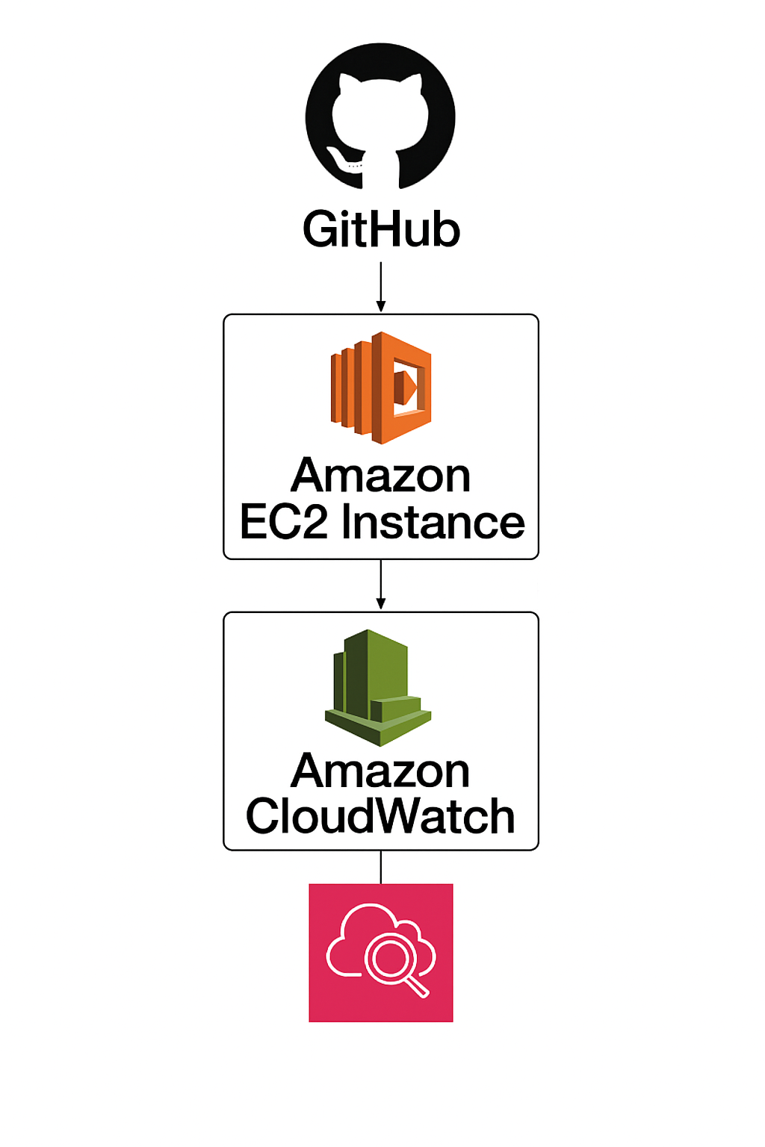

# 3. High-Level Design (HLD)

Source Control (GitHub Actions), Build & Quality (AWS Code Build), Artifactory (JFrog) Deployment (EC2), Monitoring (AWS CloudWatch).

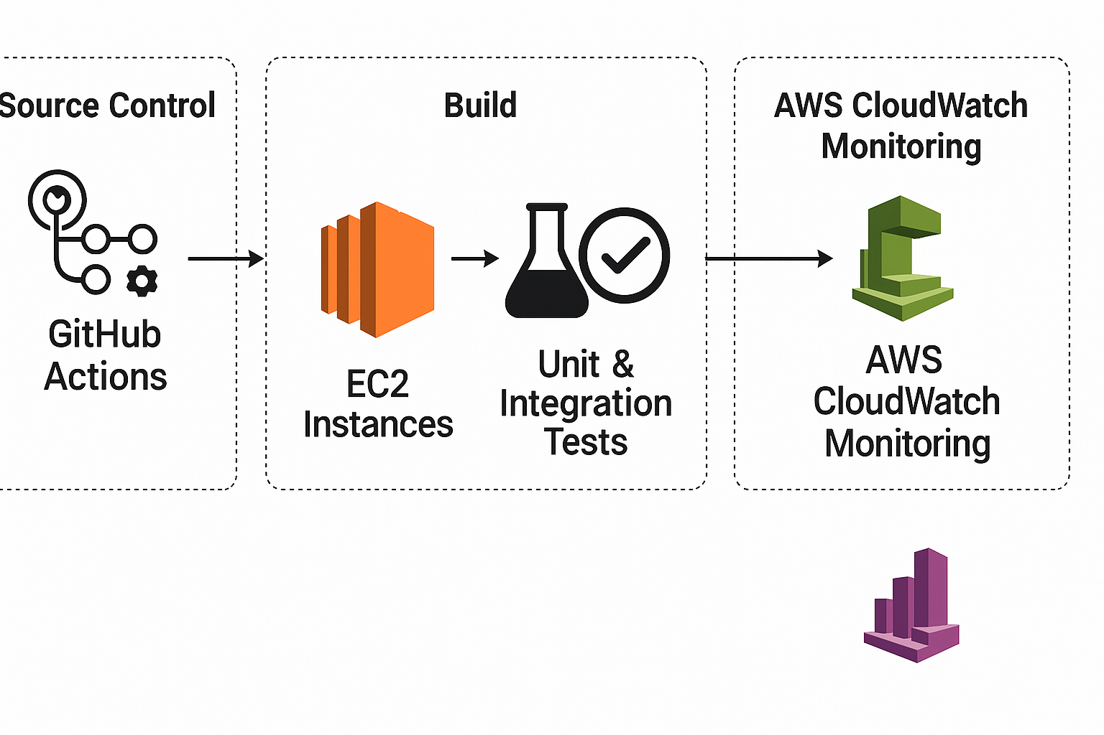

# 4. Low-Level Design (LLD)

steps: 1. GitHub Actions (Code Checkout), 2. Build, 3. unit & integration test 4. EC2 Instances, 5. AWS CloudWatch Monitoring

GitHub Actions (Code Checkout) → Code Build → Unit test → Integration Test → Artifactory Repository→ EC2 Instances→ CloudWatch Monitoring

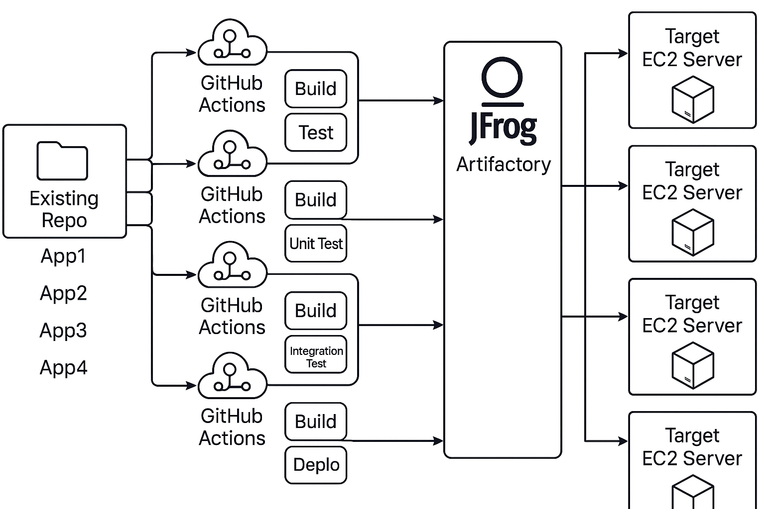

# 5.Dev Environment Workflow

1. Developer pushes code to GitHub.
2. GitHub Actions triggers the pipeline.
3. AWS Code Build builds the application.
4. Performing Unit & Integration Tests
5. Store Artifacts in JFrog Artifactory.
6. Pull artifacts from Artifactory, Deploy using SCP.
7. Enable detailed monitoring.AWS CloudWatch monitors the deployment.
8. Set alarms for CPU, memory, and application health.

# Dev CI/CD Pipeline –

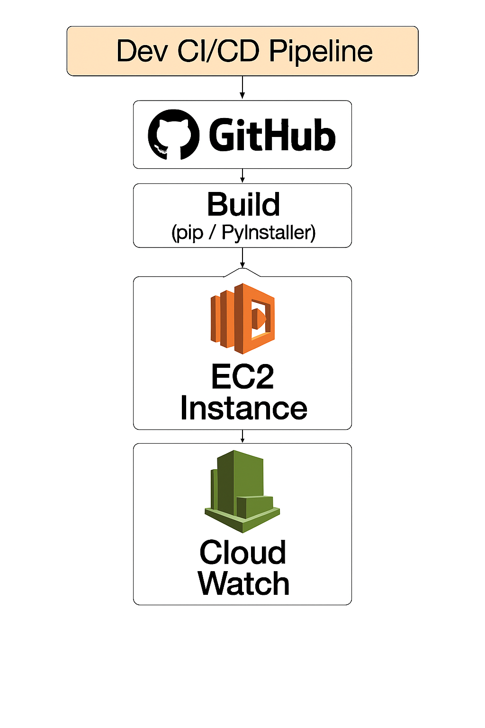

# Prod CI/CD Pipeline –

5.1 Prod Environment Workflow

1. **Source Code Management**

Developer pushes code to **GitHub** (main branch for Prod).

1. **Build Stage**

Use **pip / PyInstaller** to build the application.

1. Install dependencies and package the application.

**Manual Approval**

A gate for human validation before deploying to production.

1. Ensures compliance and reduces risk.
2. **Deployment**

Deploy the application to **EC2 Instance**.

Configure environment variables and security groups.

1. **Monitoring**

Use **AWS CloudWatch** for:

* 1. Logs (application/system)
  2. Metrics (CPU, memory, network)
  3. Alarms for failures or performance issues.

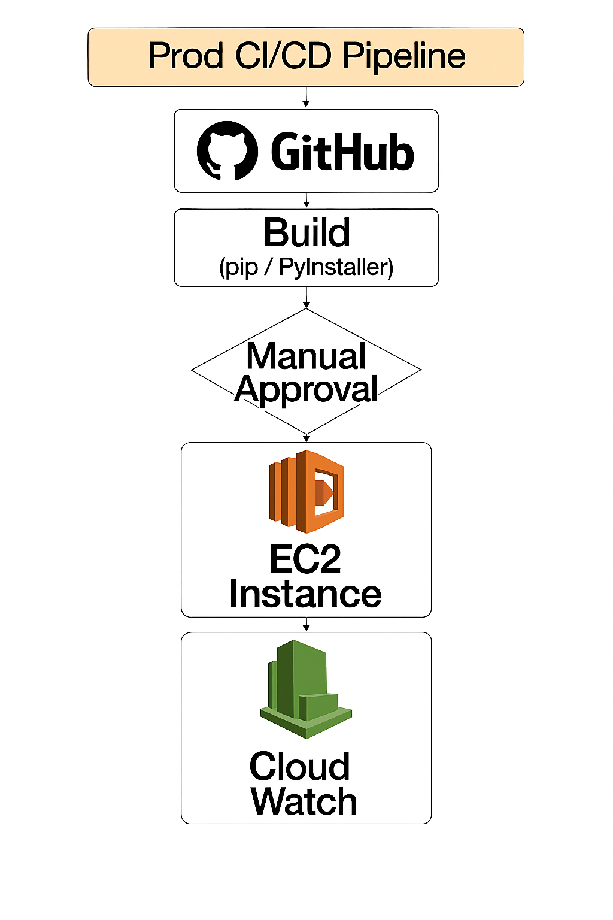

# 6. Non-Functional Requirements

* Scalability: Supports scaling EC2 instances based on load.
* Security: Trivy ensures vulnerability scanning; IAM roles restrict access. Additional measures include secrets management using AWS Secrets Manager and network isolation through security groups and VPC configurations.
* Observability: CloudWatch provides metrics, logs, and alarms.

# 7. Pros & Cons

## Pros:

* Fully automated CI/CD pipeline.
* Integration with AWS native services.
* Code quality and security checks included.

## Cons:

* Tight coupling with AWS services.
* Requires setup and maintenance of SonarQube and Trivy.

# 8. Future Enhancements

* Introduce Blue/Green deployments for zero-downtime releases.
* Add support for multi-cloud deployment.
* Integrate with Kubernetes (EKS) for container orchestration.

[Figure 1: High-Level CI/CD Architecture Diagram]

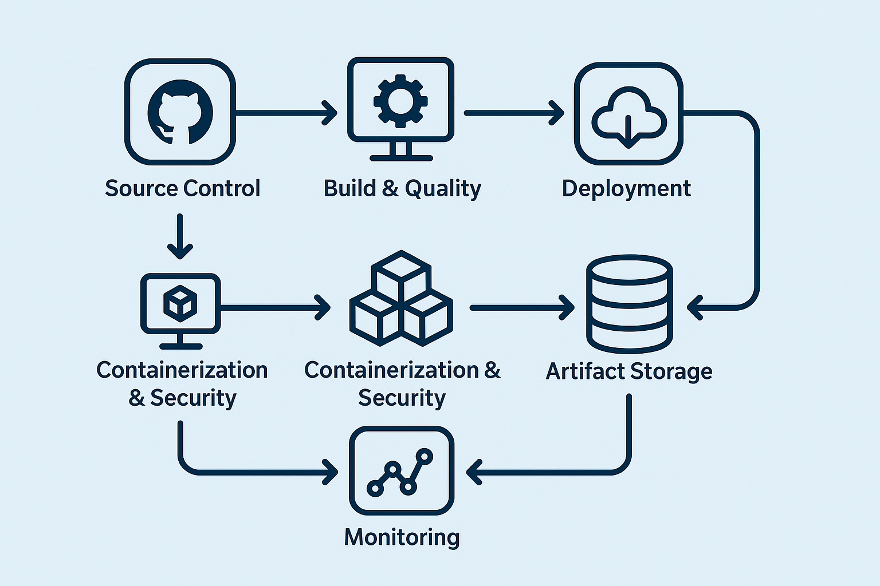

[Figure 2: Low-Level Pipeline Workflow Diagram]

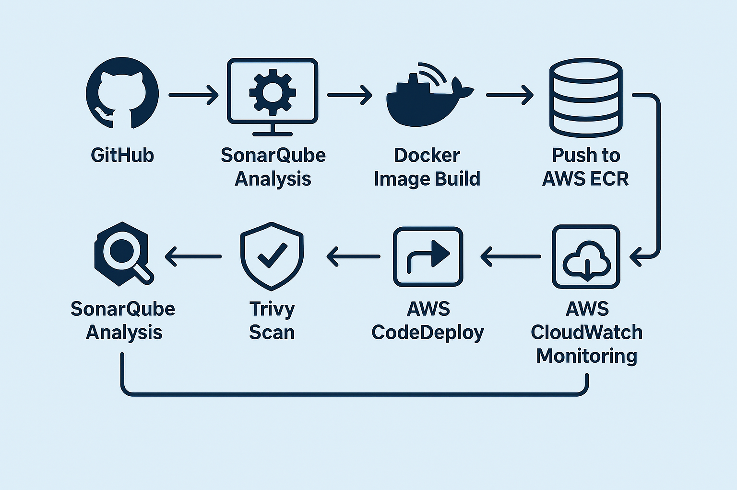

# 9. Glossary

ECR: Elastic Container Registry - AWS service for storing Docker images.

EC2: Elastic Compute Cloud - AWS virtual server hosting service.

Trivy: Security scanner for container images.

IAM: Identity and Access Management - AWS service for access control.

CI/CD: Continuous Integration / Continuous Deployment.

Branching Strategy –

1.Main

* Always production-ready code.
* Tagged for releases.

2. **Develop**

* Integration branch for features.
* Used for QA and staging.

3.**Feature Branches**

* Created from develop.
* For new features or enhancements.
* Merged back into develop.

4.**Release Branches**

* Created from develop when preparing a release.
* Bug fixes and final testing happen here.
* Merged into main and develop.

5. **Hotfix Branches**

* Created from main for urgent fixes.
* Merged back into main and develop.

